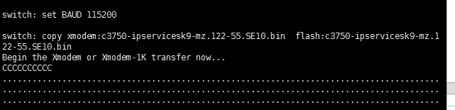

|  |  |  |
| --- | --- | --- |
|  | C:\Users\Administrator\AppData\Roaming\Tencent\Users\860072661\QQ\WinTemp\GE\0D4F43D5-D71A-45E1-9EAD-37D17AA4A8E2.jpg |  |

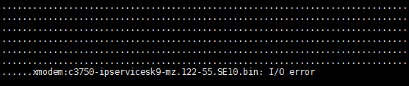

But HyperACCESS will ok (same with 115200)

